**P.E JEWELLERY**

***Group Members***

|  |  |  |
| --- | --- | --- |
| *S.no* | *Student ID* | *Student Name* |
| 1 | Student1348437 | Wafia baqar |
| 2 | Student1336481 | Ayesha siddqui |
| 3 | Student1333176 | Fareena khan |

**Project Advisor**

**Respected Sir Muhammad Farhan**



**Aptech Computer Education**

**Korangi Center**

**ACKNOWLEDGEMENT**

First of all we would like to thank ALLAH the almighty who make us able to complete this project.

After that we would like to express profound gratitude to our internal project advisor, Center Senior Faculty**, Sir Muhammad Farhan** for her precious support, back-up, supervision and useful suggestions throughout this project. Her moral support and continuous help enabled us to complete our work successfully

We are grateful to the faculty members of Aptech Korangi Center who were always there to help us despite of their personal workload.

We are as ever, especially indebted to our parents for their love and support throughout our life. We also wish to thank our classmates, friends and all the individuals or groups that were involved in this project by any mean.

|  |
| --- |
| Wafia baqar  Ayesha sidiiqui |

* **E-Project** **Synopsis**
* **Introduction**

At Pascal imitation jewellery you are provided with 100% Quality and Trustable Products.

AT Pascal imitation jewellery you are able to shop with Ease plus Low Prices .

Pascal jewellery Always Provides High Quality and A High Range Of Products Mainly Available Only at Ours!

You can Easily Order with Trust from Our Website instead Of taking out time of your Business or Laziness.

At Pascal jewellery you are provided with The Latest Released Products Just A Step Away From Your Doorstep!

The thirst for learning, upgrading technical skills and applying the concepts in real life environment at a fast pace is what the industry demands from IT professionals today. However busy work schedules, far-flung locations, unavailability of convenient time-slots pose as major barriers when it comes to applying the concepts into realism. And hence the need to look out for alternative means of implementation in the form of laddered approach.

The above truly pose as constraints especially for our students too! With their busy schedules, it is indeed difficult for our students to keep up with the genuine and constant need for integrated application which can be seen live especially so in the field of IT education where technology can change on the spur of a moment. *Well, technology does come to our rescue at such times!!*

Keeping the above in mind and in tune with our constant endeavour to use Technology in our training model, we at Aptech have thought of revolutionizing the way our students learn and implement the concepts using tools themselves by providing a *live and synchronous eProject learning environment!*

**Hardware/ Software Requirements**

**Hardware**

* A minimum computer system that will help you access all the tools in the courses is a Pentium 166 or better
* 64 Megabytes of RAM or better

**Software**

* Notepad/HTML editor
* Dreamweaver
* IE 5.0/ Netscape 6.0

**Problem Statement**

“PASCAL IMITATION JEWELLERY” is one of the leading manufacturers and suppliers

of Precious, Semi precious and Artificial Jewelry. They sell them under different

brand names. The Quality of the products are renowned for striking features such as

smooth polish, stunning design and excelling clarity, look and feature, luster. The

shop owner wishes to have the website of the jeweler shop where in they want to

describe all the type, brands of the product.

* **Objective**
* The Objective of this program is to give a sample project to work on real life projects. These Website help you build a larger more robust Website.
* The objective is not to teach you topic but to provide you with a real life scenario and help you create basic Websites using the tools.
* You can revise these chapters before you start with the project.
* These programs should be done in the Lab sessions with assistance of the faculty if required.
* It is very essential that a student has a clear understanding of the subject.
* Kindly get back @ eprojects@aptechfze.ae in case of any doubts regarding the Website or its objectives.

**So what is this eProject?**

eProject is a step-by-step learning environment that closely simulates the classroom and Lab based learning environment into actual implementation. It is a project implementation at your fingertips!! An electronic, live juncture on the machine that allows you to

* Practice step by step i.e. laddered approach.
* Build a larger more robust application.
* Usage of certain utilities in applications designed by user.
* Single program to unified code leading to a complete application.
* Learn implementation of concepts in a phased manner.
* Enhance skills and add value.
* Work on real life projects.
* Give a real life scenario and help to create applications more complicated and useful.
* Mentoring through email support.

The students at the centre are expected to complete this eProject and send complete project along with the documentation to eProjects Team

Looking forward to a positive response from your end!!

* **Technology Used**

In order to meet the requirement of our project we have used following underlying technologies.

* HTML 5
* CSS 3
* Bootstrap 5
* JavaScript
* Font Awesome
* AOS Animation

*Figure 1: Technology Used in Project*

* **Website Features**
* We have used bootstrap framework so as to make our website responsive. Although it is not as responsive as professional websites are, but we have tried basic implementation of a responsive website.
* Smooth hovering effects have been used.
* Color combination is according to Logo.
* Easily Find Any Product
* **The Requirments of The Site Were**

Requirement Specification:

The Web site is to be created based on the following requirements.

1) The home page must describe the keywords or highlight of the shop along

with all navigation link defined.

2) The product must be categorized as per the “Brand”.

3) It should be followed by sub-category with the type (Original, Semi Precious,

and Artificial).

4) Proper description of the product along with the image must be added in the

website.

5) Comparison of the product must be included in the website. (like comparison

between product designing same but one will be semi-Precious and other

Artificial and so on).

6) Contact Us

7) About Us

8) Feedback form

9) Gallery section should be added.

10) Color combination must be uniform throughout the project.

11) Navigation must be smooth.

|  |  |  |  |  |  |
| --- | --- | --- | --- | --- | --- |
|  | ***Chrome*** | ***Firefox*** | ***Internet Explorer*** | ***Opera*** | ***Safari*** |
| Android | * Supported | * Supported | * Supported | * Supported | * Supported |
| iOS | * Supported | * Supported | * Supported | * Supported | * Supported |
| Mac OS X | * Supported | * Supported | * Supported | * Supported | * Supported |
| Windows | * Supported | * Supported | * Supported | * Supported | * Supported |

* **Website structure**

*Table 1: Bootstrap*

|  |  |  |  |  |
| --- | --- | --- | --- | --- |
|  | Extra Small Devices  (xs) | Small Devices  (sm) | Medium devices  (md) | Large devices  (lg) |
| Device Type | Phone (<768) | Tablets (≥768px) | Desktops (≥992px) | Desktops (≥1200px) |
| Container width | None (auto) | 750px | 970px | 1170px |
| Class prefix | .col-xs- | .col-sm- | .col-md- | .col-lg- |
| No. of columns | 12 | | | |
| Columns width | Auto | ~62px | ~81px | ~97px |
| Gutter width | 30px (15px on each side of column) | | | |

* **Source Code Screenshoot**
* 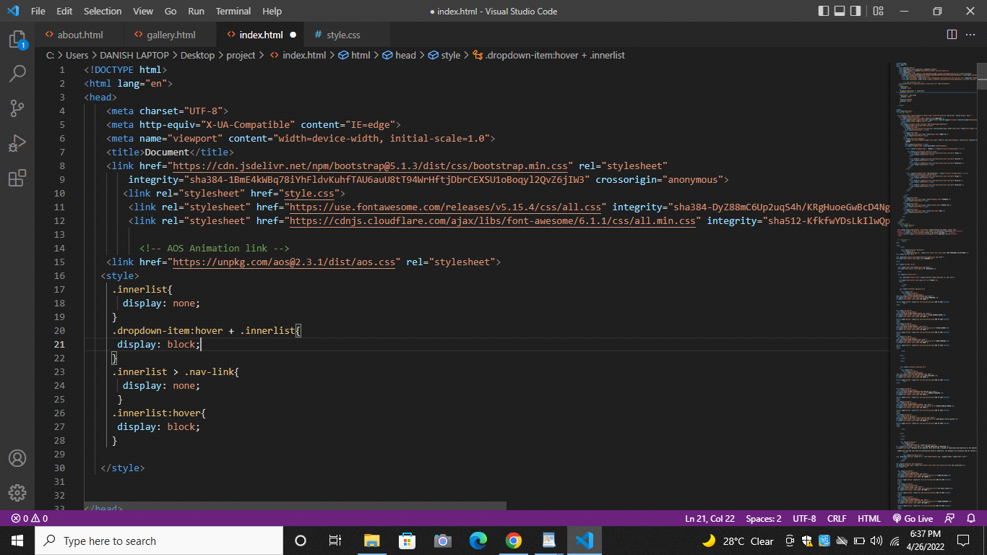
* 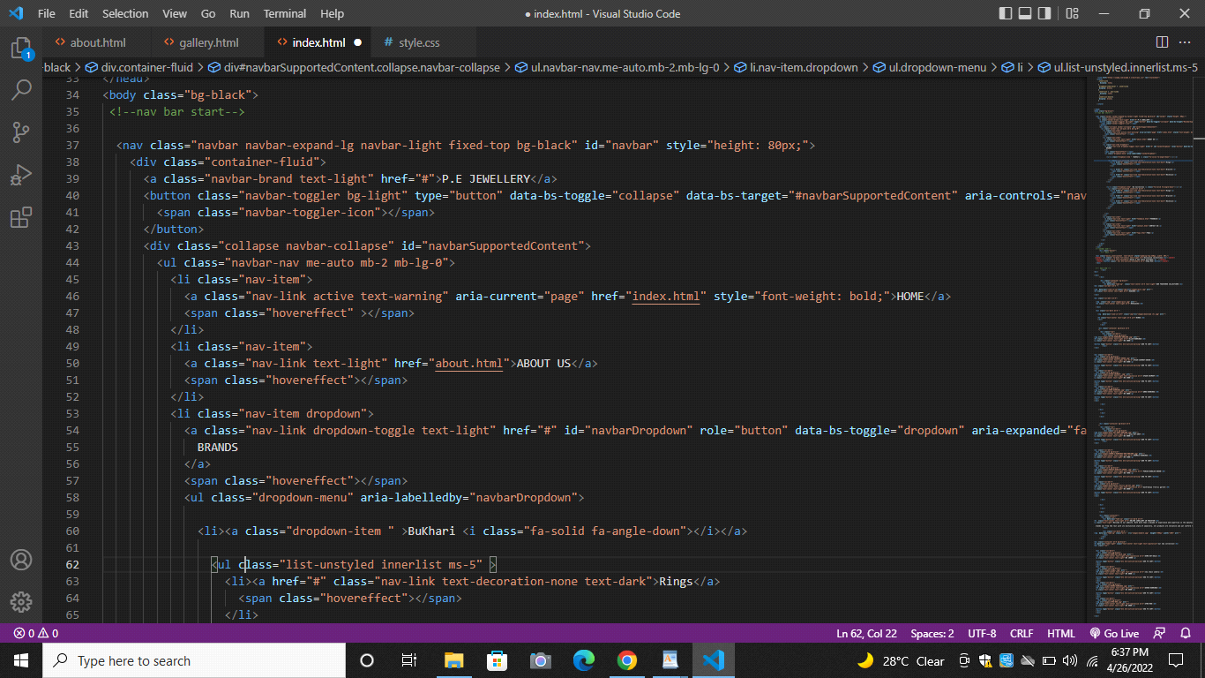
* 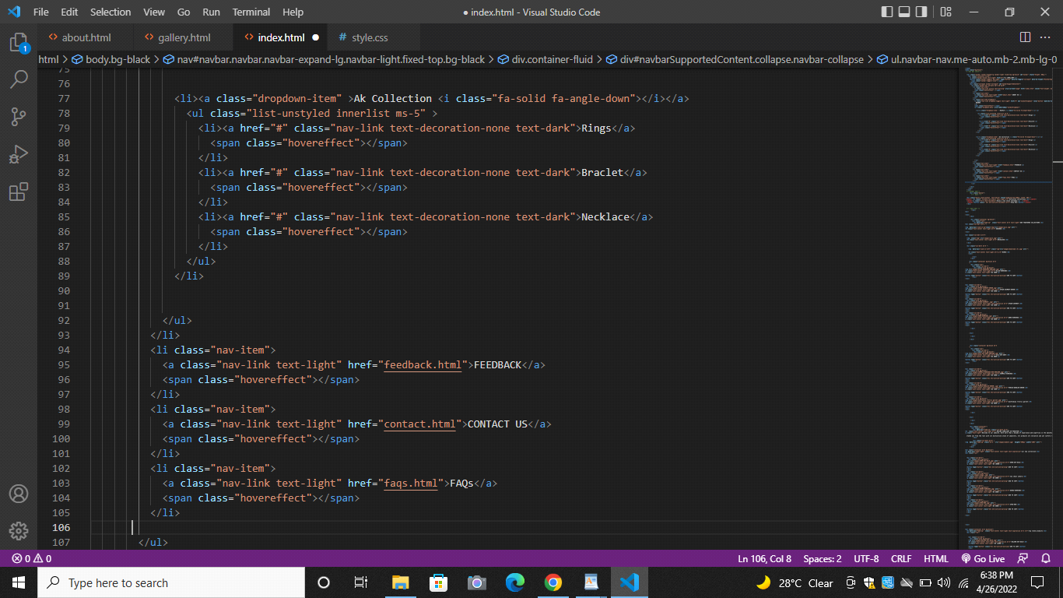
* 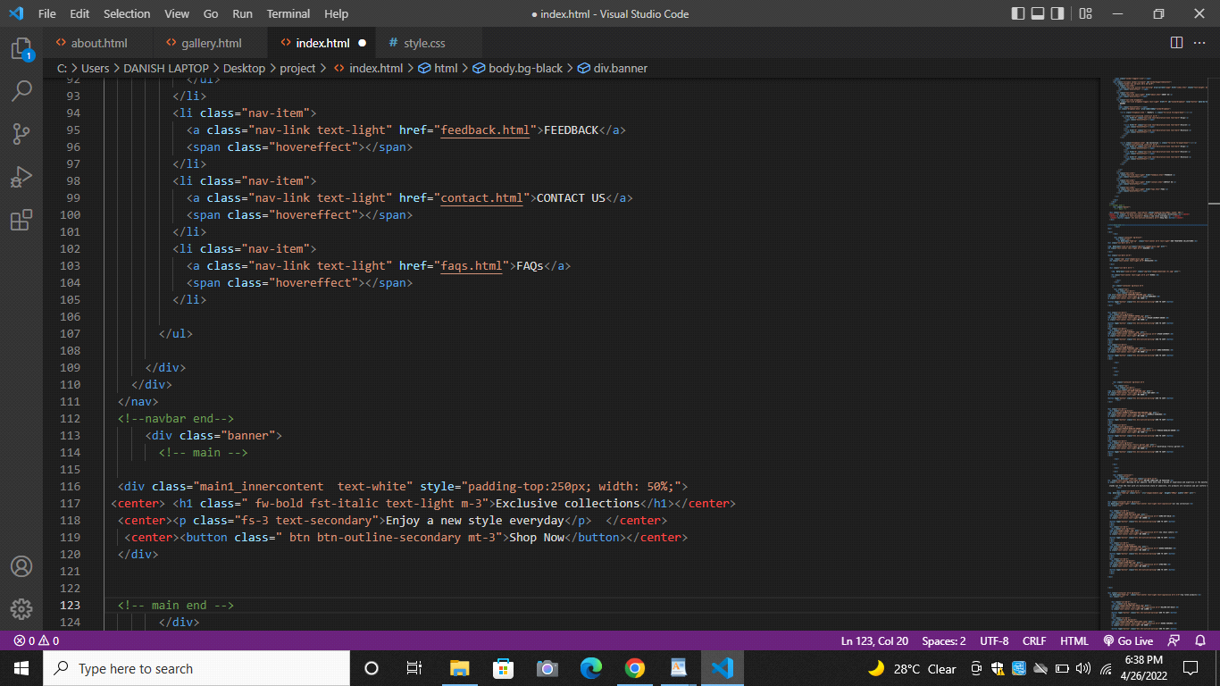
* 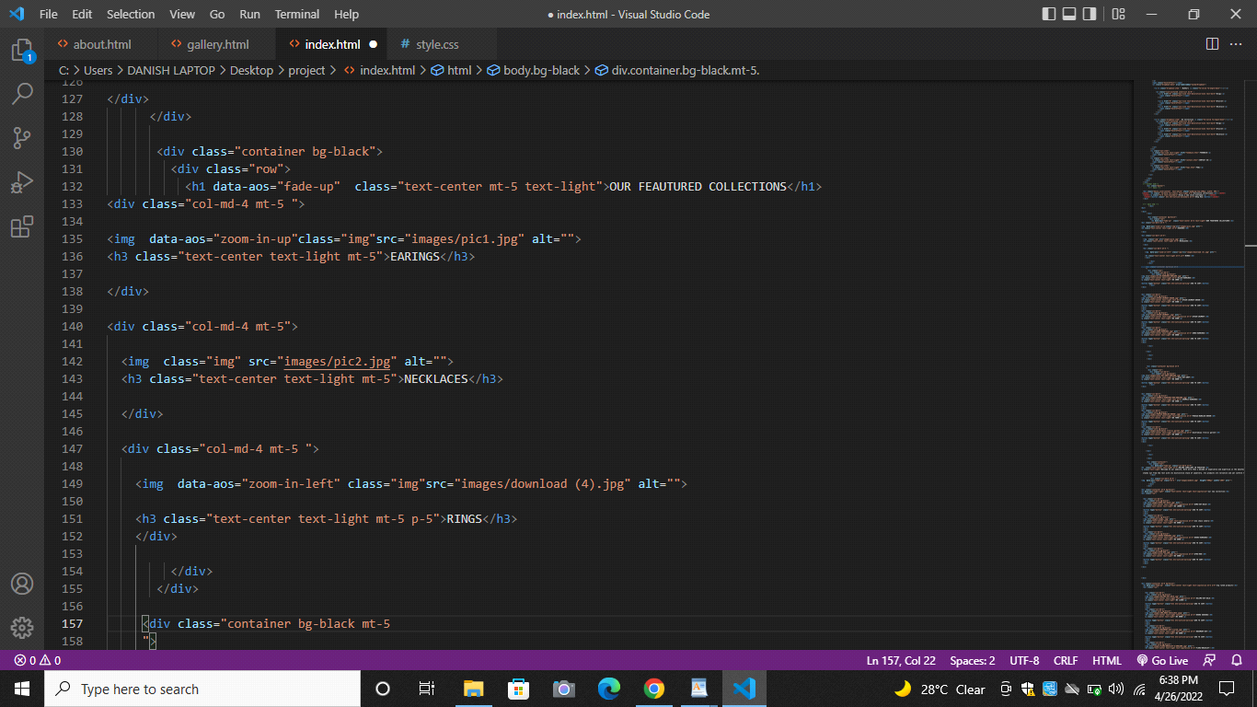
* 
* 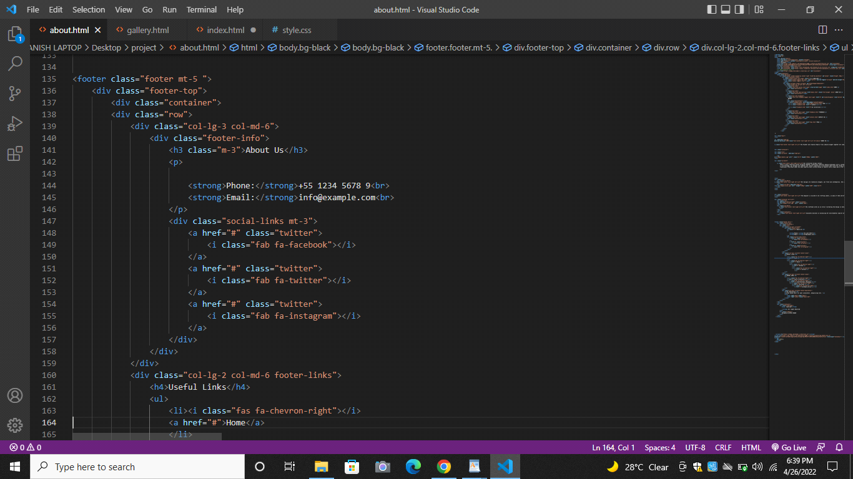
* 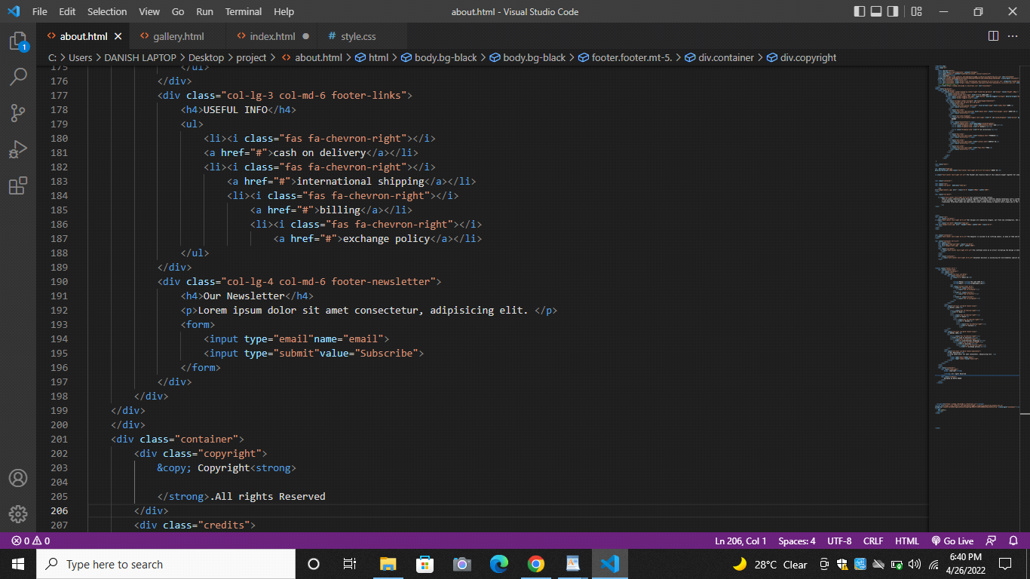

**Style Code**

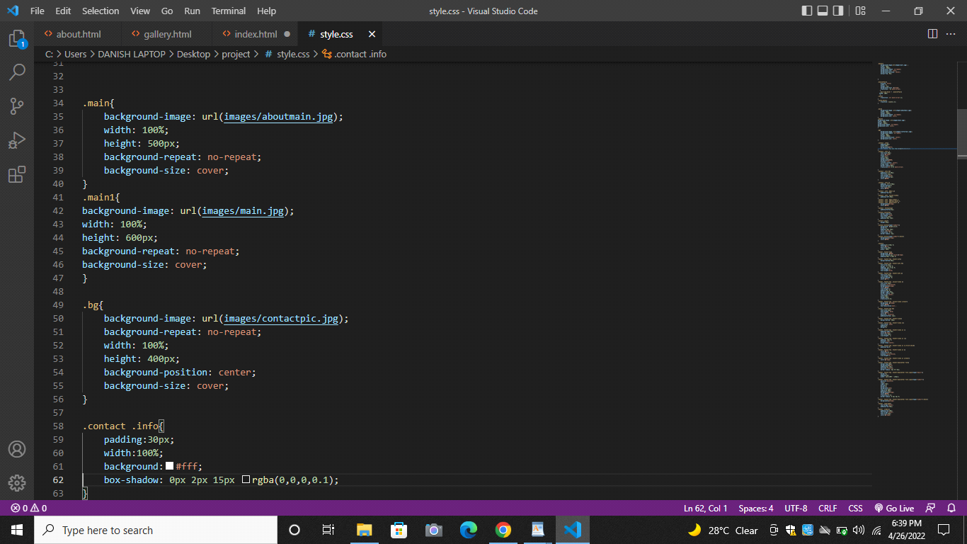

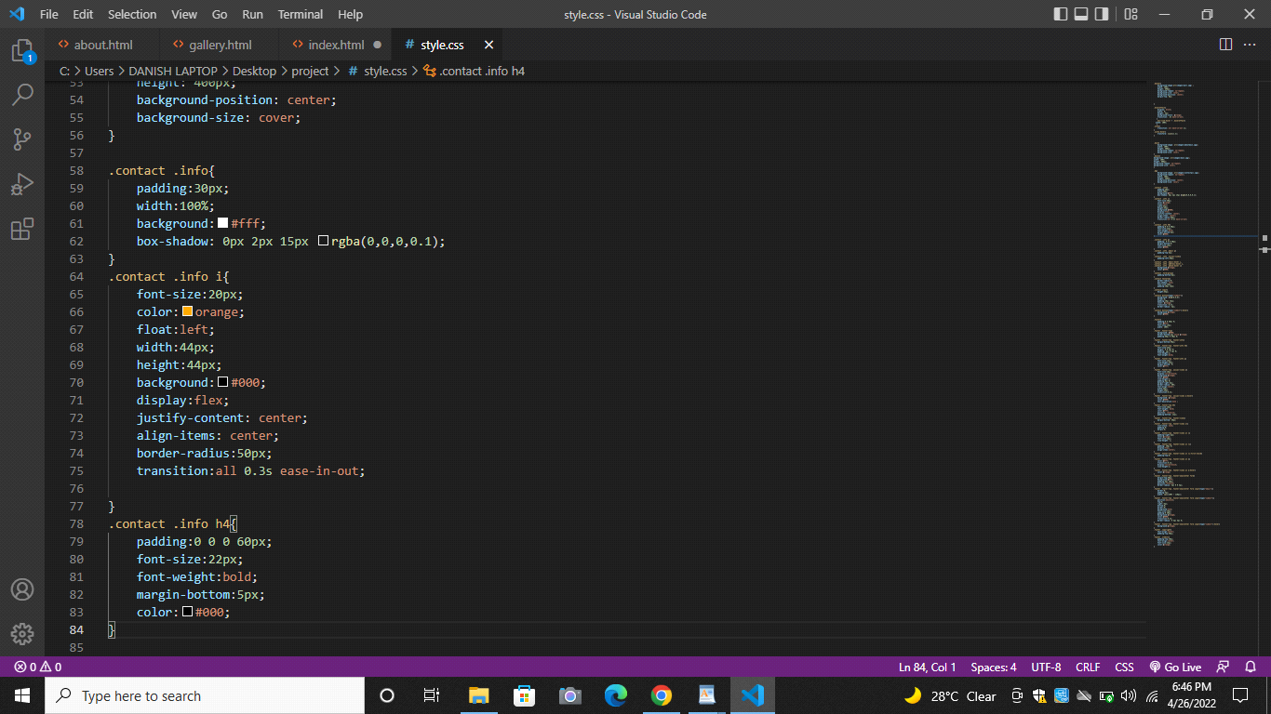

**Site Screenshoots**

**Home Page**

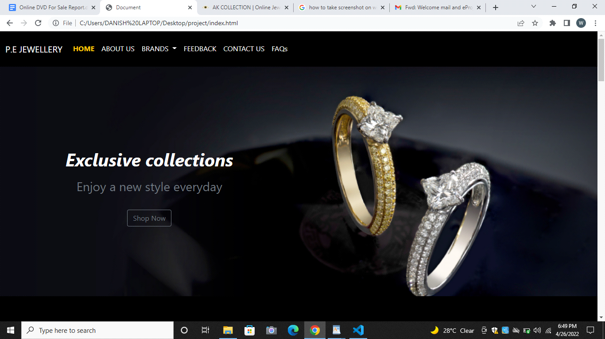

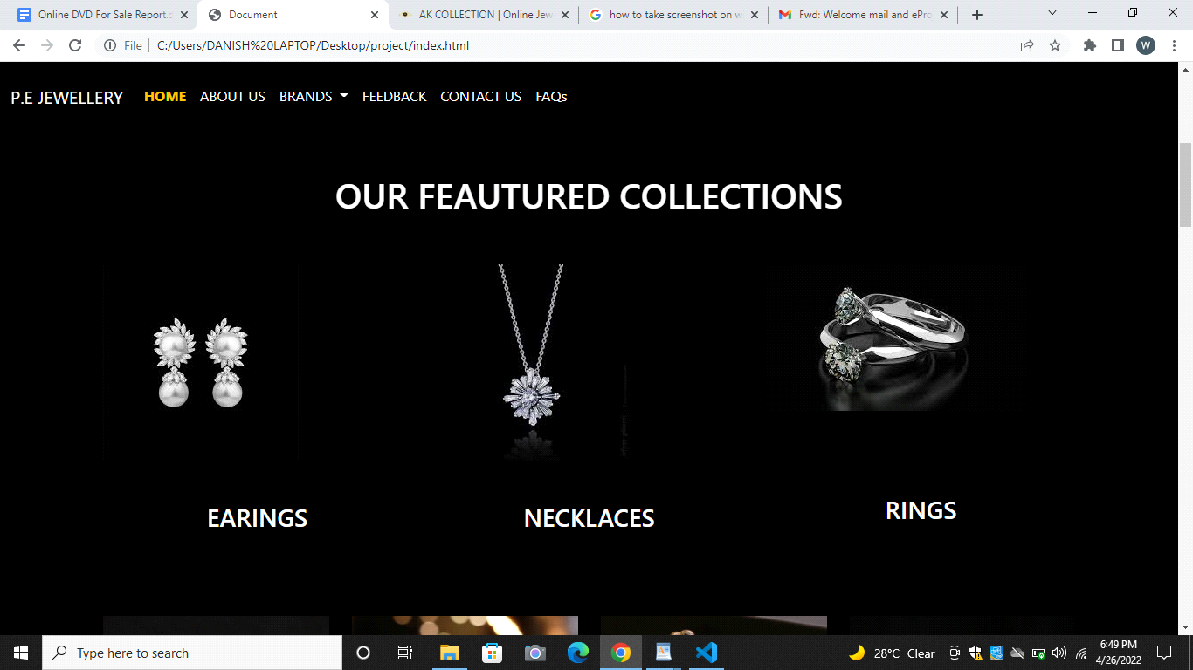

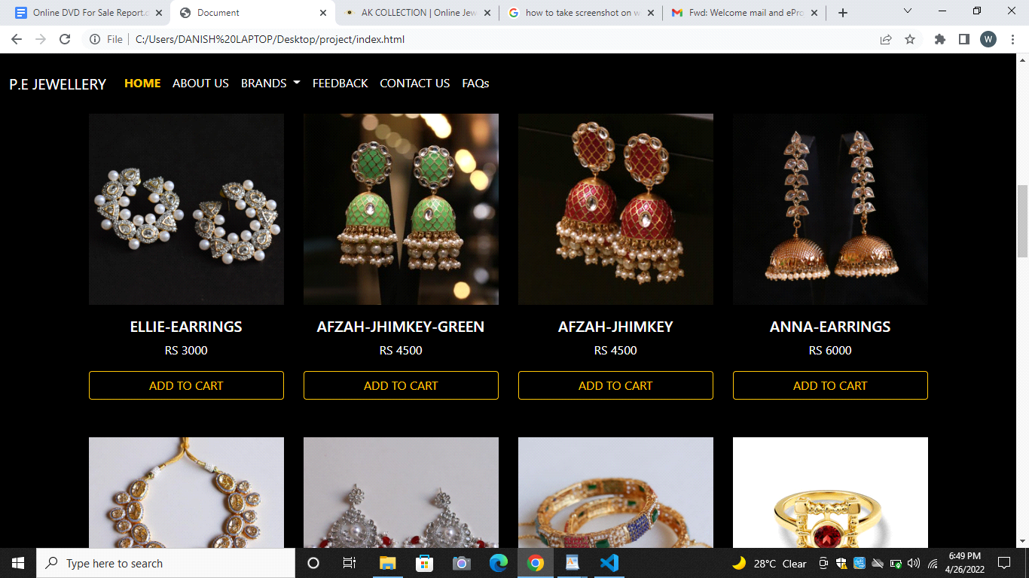

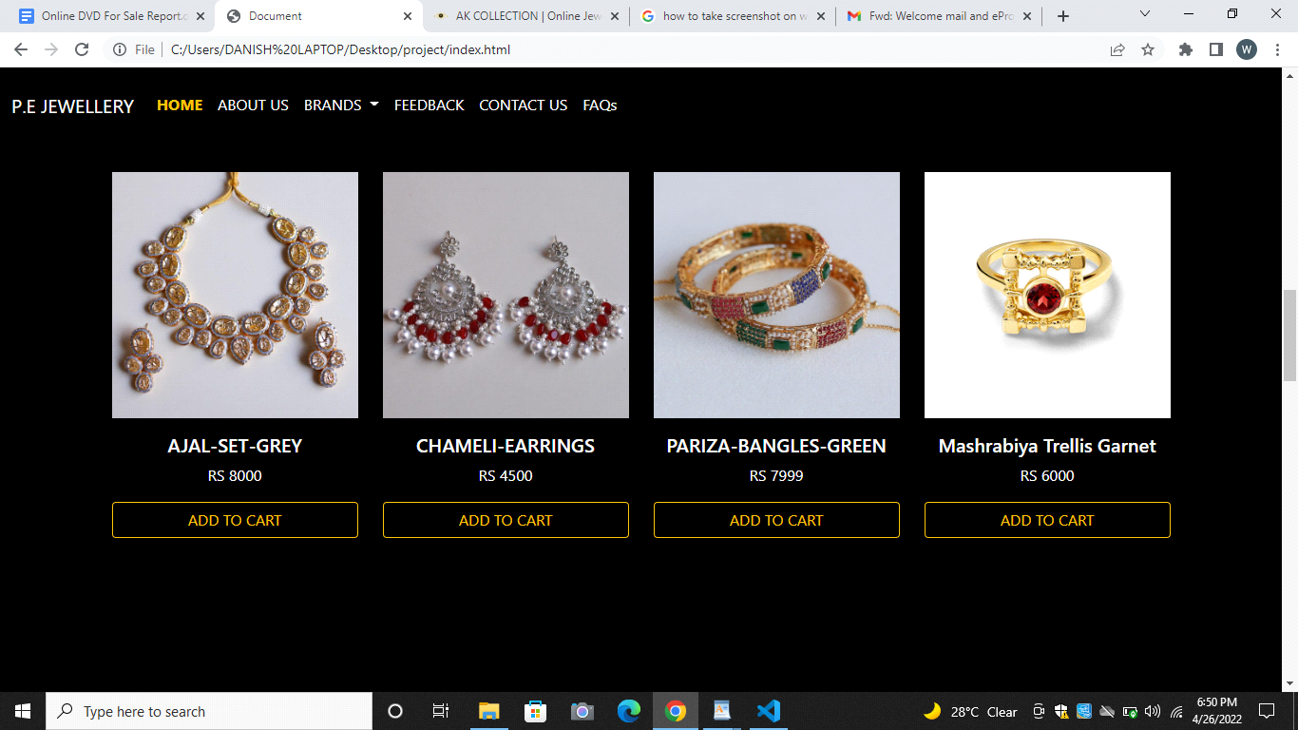

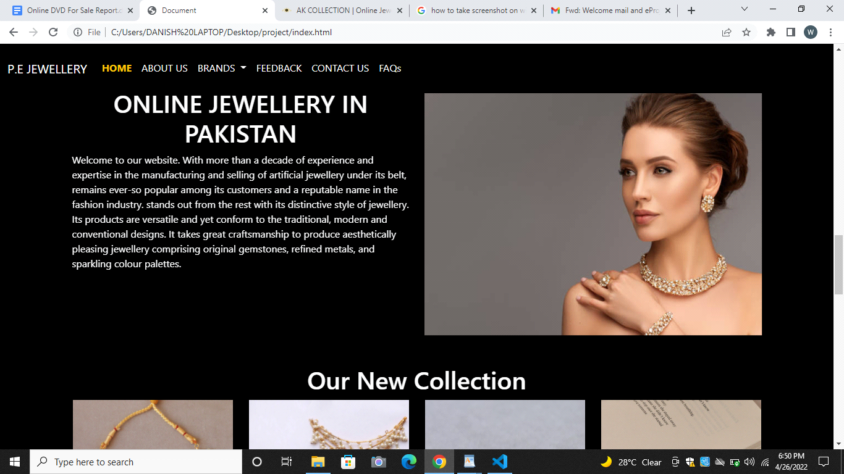

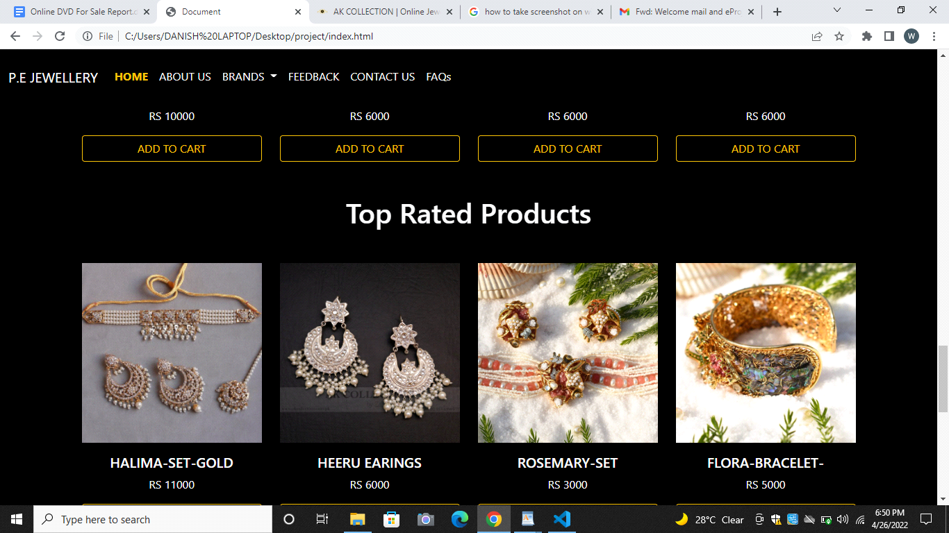

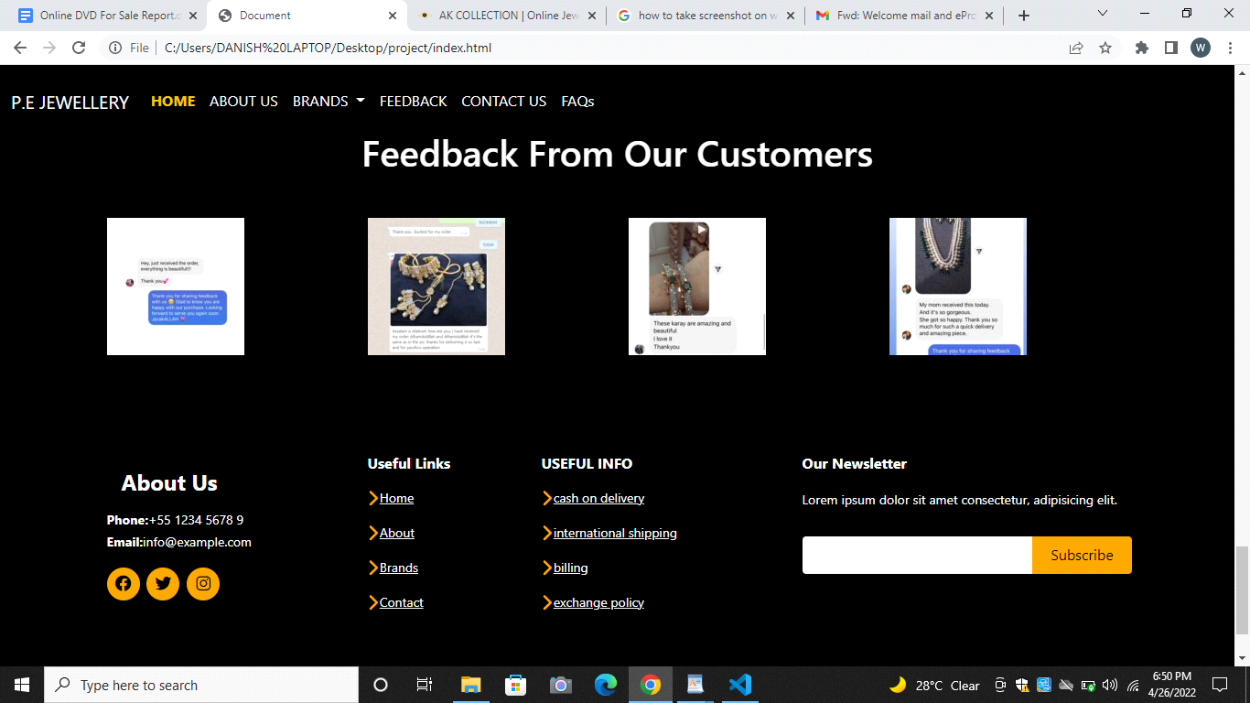

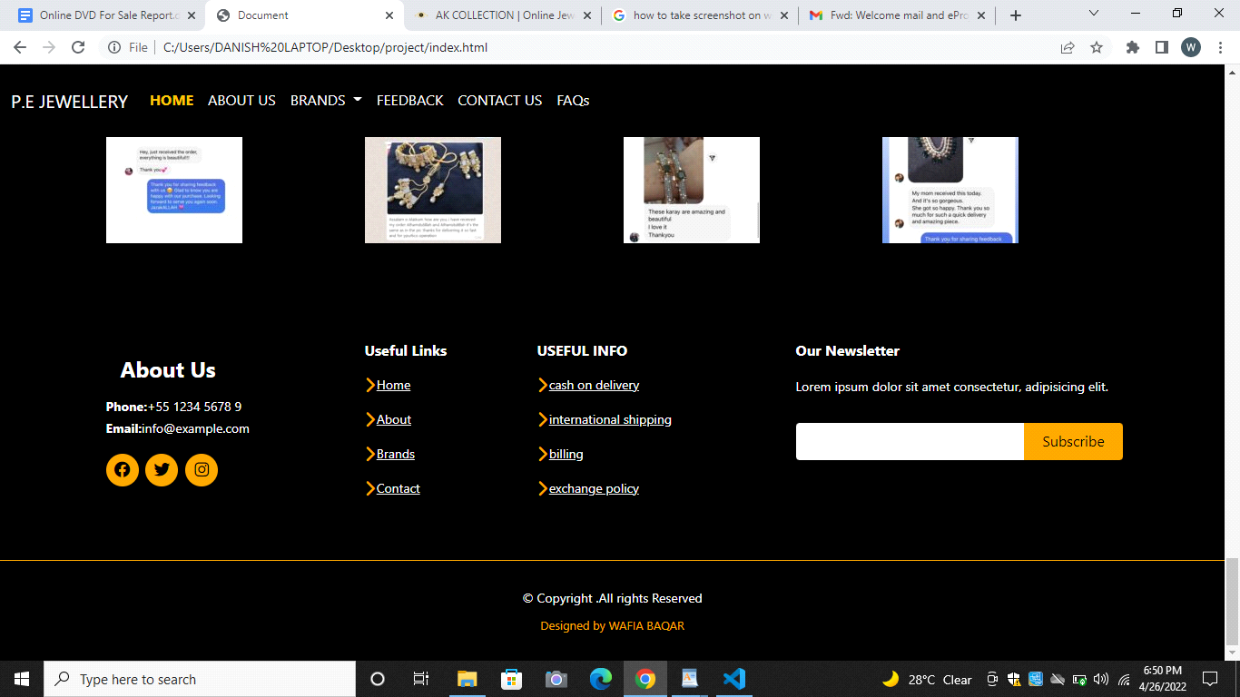

**About Page**

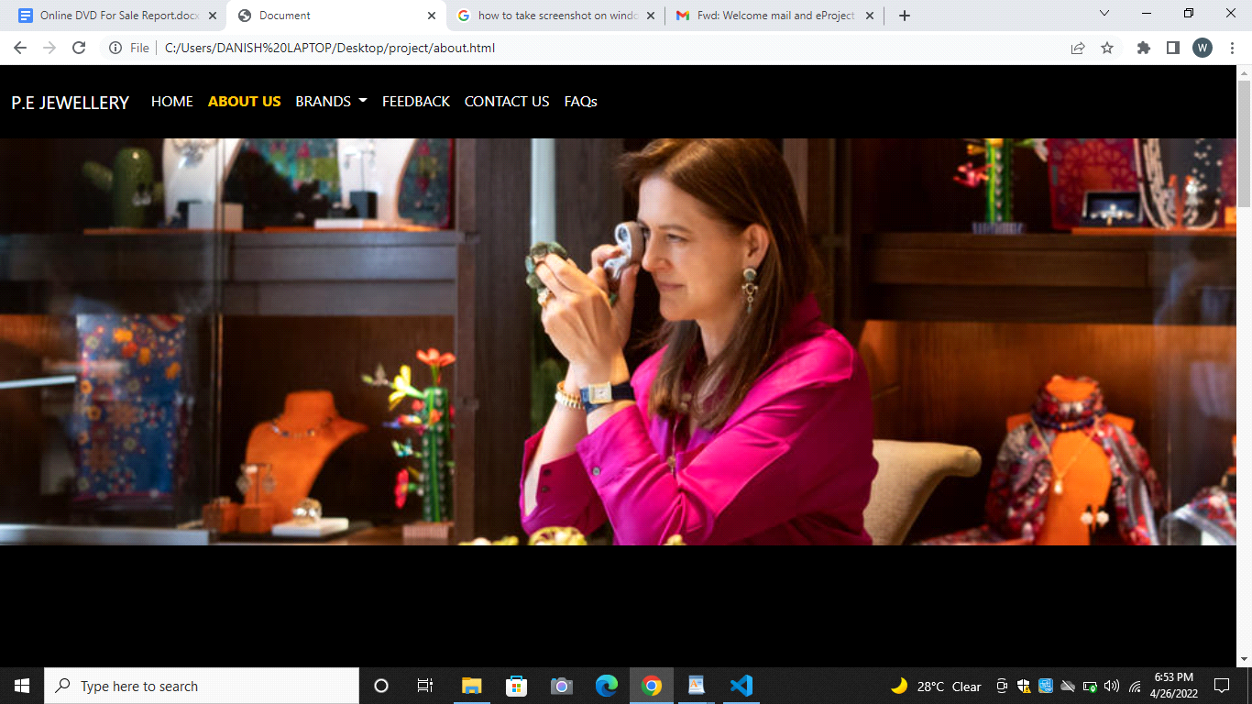

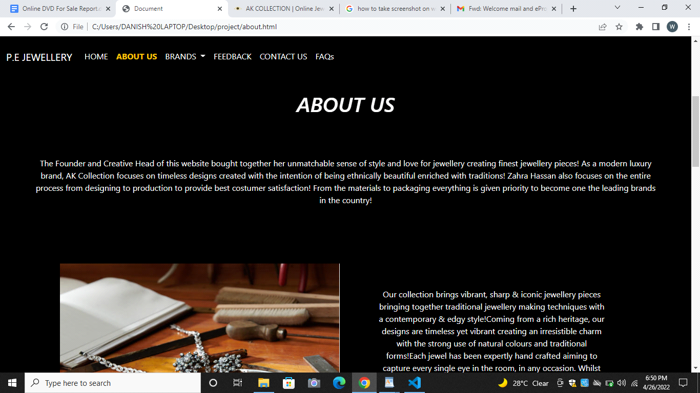

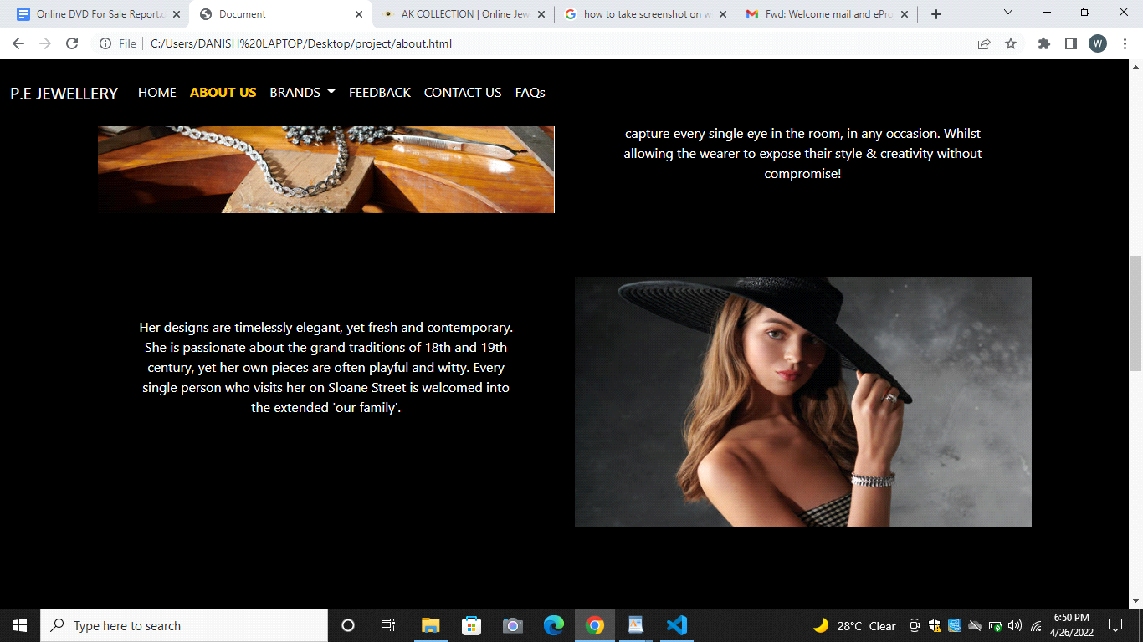

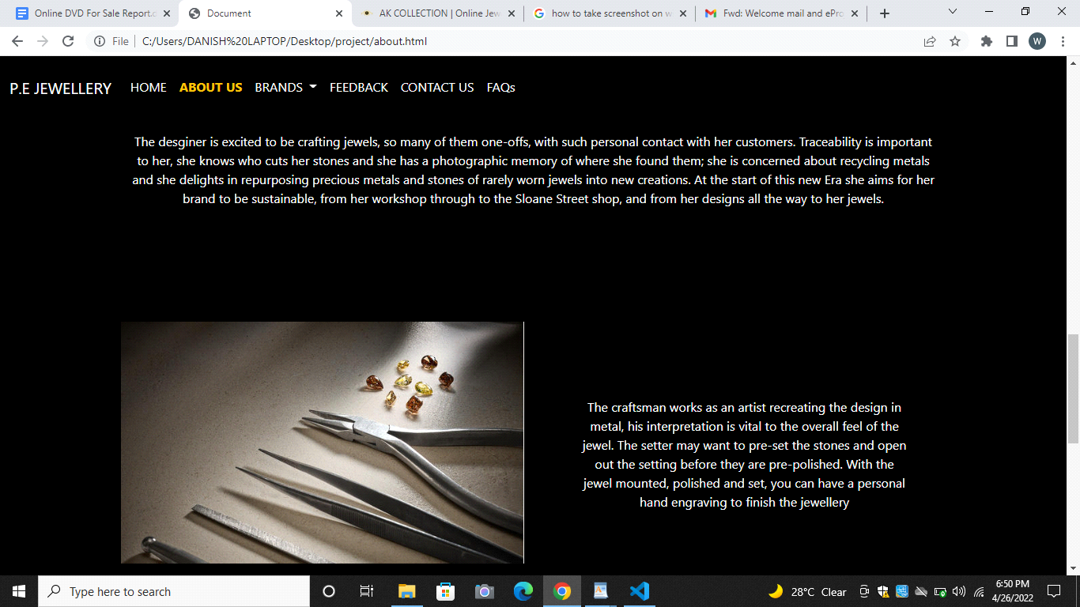

**CONTACT PAGE**

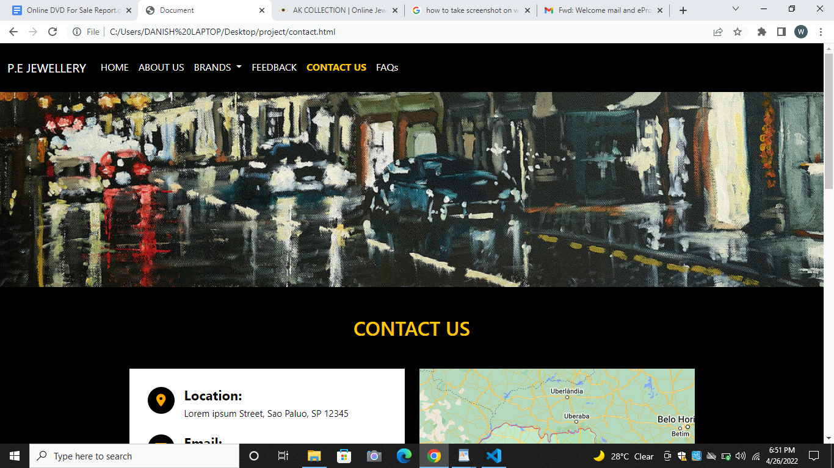

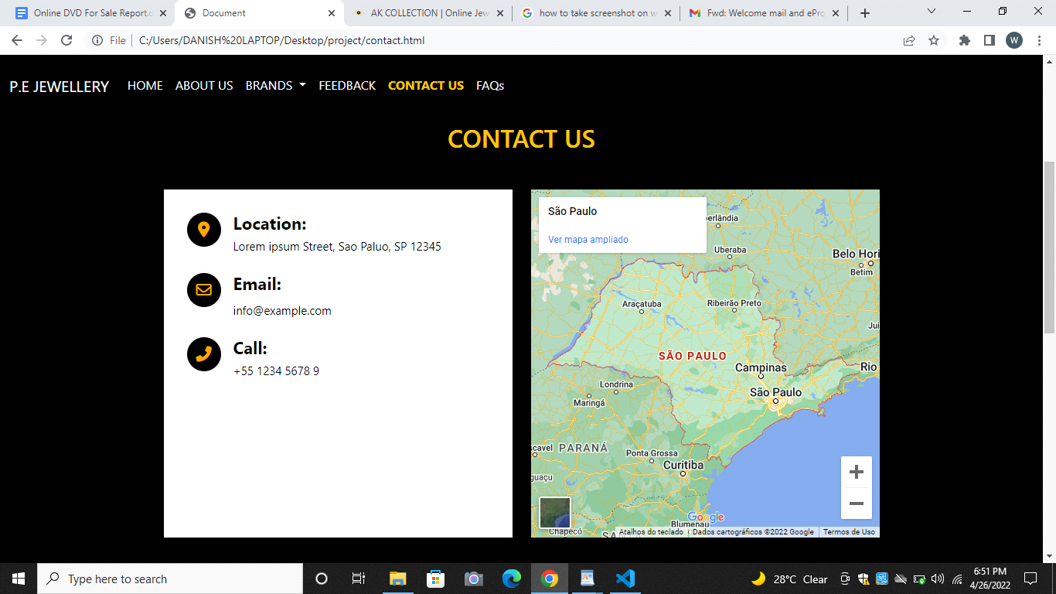

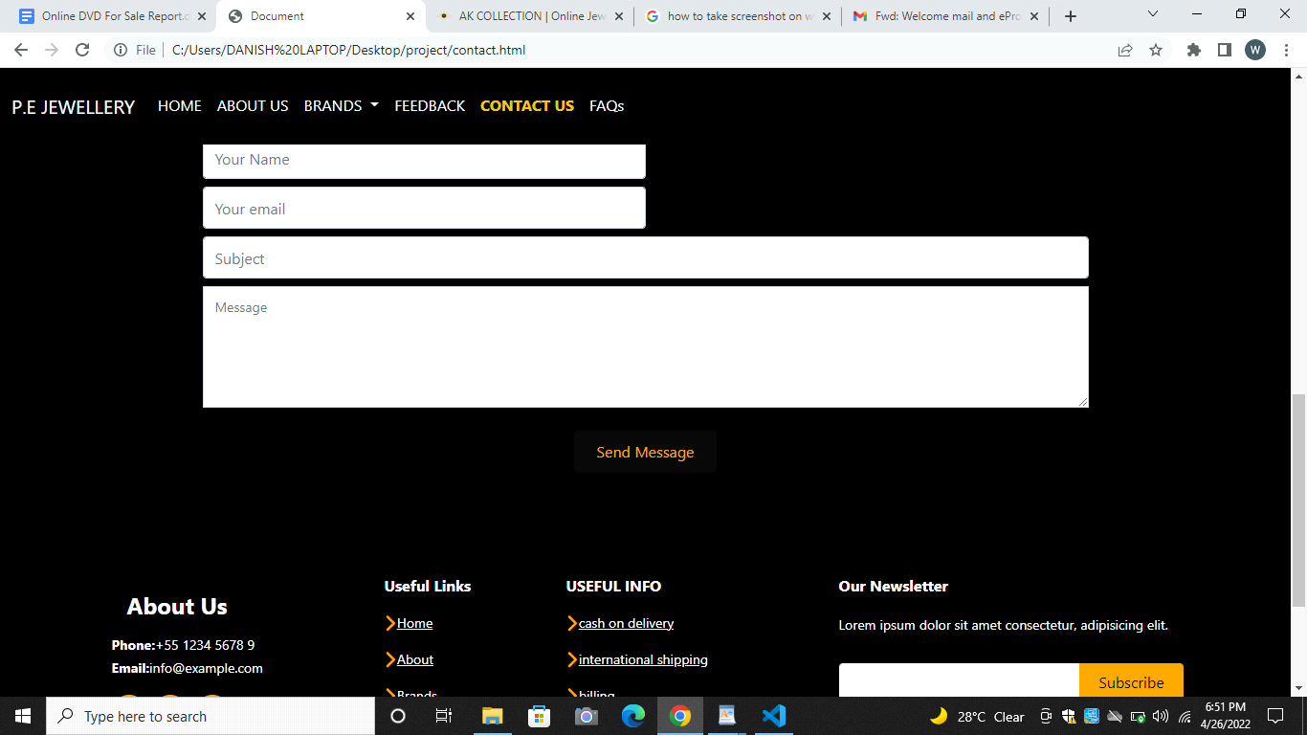

**FAQs**

